**CASE STUDY ON COFFEE VENDING MACHINE**



**B-Tech/II Year CSE/IV Semester**

**19CSE214/Theory of Computation**

|  |  |
| --- | --- |
| Roll no | Name |
| CB.EN.U4CSE21117 | **MANVISH D** |
| CB.EN.U4CSE21138 | **SURYA N** |
| CB.EN.U4CSE21148 | **CHAITANYA R** |
| CB.EN.U4CSE21164 | **JASWANTH U** |
| CB.EN.U4CSE21166 | **GOWTHAM V** |

**Amrita School of Computing, Coimbatore**

**Department of Computer Science and Engineering**

**2022 -2023 Even Semester**

**PROBLEM STATEMENT​:**

* Implementing a Finite State machine for a vending machine with certain features that sells beverages
* Design the state transitions and define the states necessary to implement the behaviour of the vending machine
* Consider various user interactions, potential errors, and the appropriate feedback/messages to provide a smooth and user-friendly eKperience.

# METHODOLOGY​:

* Initially, vending machine is in the initial state, waiting for user interaction. When a user approaches the vending machine, it transitions to the welcome state
* In the welcome state, the vending machine presents the available beverage options to the user, such as coffee, tea, milk, or hot chocolate.
* The user can select one of the available beverage options.
* After the user selects a beverage, the vending machine transitions to the payment state.
* In the payment state, the vending machine provides payment options to the user, such as cash or UPI.
* If the user selects the cash option, the vending machine transitions to the cash payment state, awaiting the user to insert the required amount of cash (5$).
* If the user selects the card option, the vending machine transitions to the card payment state, prompting the user to give a 4-bit pin for the machine.
* Once the payment is successfully processed, the vending machine transitions to the dispensing state.
* In the dispensing state, the vending machine prepares and dispenses the selected beverage to the user.
* After dispensing the beverage, the vending machine transitions to the transaction complete state and displays a transaction completion message.
* If the selected beverage is out of stock, the vending machine transitions to the unavailable state and prompts the user to the select state again.
* If the payment fails or is insufficient, the vending machine transitions to the payment failure state and prompts the user to idle.
* Once the transition reaches complete state the process is successfully completed.

**ALPHABET SET:**

**Alphabets (Σ):**

Alphabets are set of symbols, which are always finite. In our case, they are​

​

∑ACTION - {w,l,c,b,q,g,a,n,d,K,o,v,t,y,s,i,j,z}

∑EVENTS - {r1,r2,r3,r4,r5,r6,r7,r8,r9,r10,r11,r12,r13}​

**GRAMMAR:**

* Grammar G for Online banking system is defined as the set {V, T, S, P} where, ​
* V is the set of non-terminal symbols: {A,B,C,D,E,F,G,H,I,J,K} ​
* T is the finite set of terminal symbols: {w,l,c,b,q,g,a,n,d,K,o,v,t,y,s,i,j,z,**λ**} ​
* S is the set of starting symbols: {A} ​
* P is the production rules and are listed below

**Transition states:**

1.(Start, B, Z) → (Service, BZ)

2.(Start, S, Z) → (Select, SZ)

3.(Select, T, S) → (Thumps Up, TS)

4.(Select, C, S) → (Coke, CS)

5.(Select, M, S) → (Mirinda, MS)

6.(Select, R, S) → (Red Bull, RS)

7. (Service, L, Z) → (Start)

(Service, L, B) → (Service)

8.(Thumps Up, L, N) → (Unavailable, N)

9.(Coke, L, N) → (Unavailable, N)

10.(Mirinda, L, N) → (Unavailable, N)

11.(Red Bull, L, R) → (Unavailable, N)

12.(Unavailable, L, S) → (Service, L)

13.(Thumps Up, L, T) → (Payment, L)

14.(Coke, L, C) → (Payment, L)

15.(Mirinda, L, M) → (Payment, L)

16.(Red Bull, L, N) → (Payment, L)

17.(Payment, U, S) → (UPI, US)

18.(Payment, G, S) → (Cash, GS)

20.(Payment Fail, L, L) → (Payment, L)

21.(Payment, U, S) → (UPI, US)

(Payment, U, 1) → (UPI, U1)

(Payment, U, 0) → (UPI, U0)

22.(Payment, G, S) → (Cash, GS)

23.(UPI, 0, S) → (Payment Fail, S)

24. (UPI, 1, S) → (1, 1S)

25. (1, 0, 1) → (0, 01)

26. (0, 0, 1) → (Payment Fail, 01)

27. (0, 1, 0) → (1, 10)

28. (1, 1, 1) → (Payment Fail, L)

29. (1, 0, 1) → (0, 01)

30.(0, L, 0) → (Successful, L)

31.(Successful, L, S) → (Dispensing, L)

(Successful, L, K) → (Successful, L)

(Successful, L, 1) → (Successful, L)

(Successful, L, 0) → (Successful, L)

(Successful, K, S) → (Successful, KS)

32.(Dispensing, E, Z) →(Complete, L)

33.(Dispensing, D, S) → (Dispenser Failed, DS)

34.(Dispenser Failed, L, D) →(Refund, L)

35.(Payment, G, S) → (Cash, GS)

36. (Cash, K, L) → (1$, KG)

37. (1$, K, L) → (1$, K)

38. (1$, K, L) → (1$, K)

39. (1$, K, L) → (1$, K)

40.(1$, K, L) → (1$, K)

41.(1$, L, L) → (Insufficient Fund, L)

42.(1$, L, L) → (Insufficient Fund, L)

43.(1$, L, L) → (Insufficient Fund, L)

44.(1$, L, L) → (Insufficient Fund, L)

45.(Insufficient Fund, L,1) → (Refund, L)

46.(5$, L, L) → (Sufficient, L)

47.(Sufficient, L, L) → (Successful, L)

48.(Successful, L, K) → (Refund, K)

49.(Refund, L, S) → (Complete, L)

**Non-Deterministic Pushdown Automaton (NPDA):**

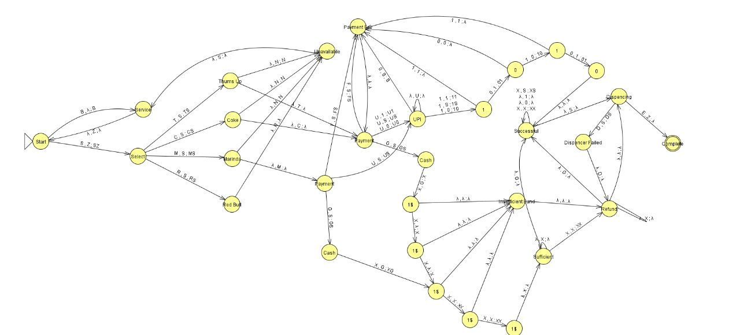

**TURING MACHINE:**

**STATES:**

1. Start: The initial state of the vending machine, waiting for user input.

2. Selecting: The user has pressed a button to select a product.

4. Dispensing: The machine is dispensing the selected product.

5. Insufficient Funds: The user has not inserted enough money to purchase the selected

product.

6. Complete: The user has successfully purchased the product.

7. Refund: The machine is refunding the user's money due to a cancellation or error.

8. Service: The machine is undergoing Service and is temporarily out

of service.

9. Coke: The machine is currently dispensing Coke.

10. Thumps Up: The machine is currently dispensing Thumps Up.

11. Mirinda: The machine is currently dispensing Mirinda.

12. Red Bull: The machine is currently dispensing Red Bull.

13. Payment: The user is selecting the payment method.

14. Cash: The user has selected to pay with cash.

15. UPI: The user has selected to pay with UPI.

16. 1$ ->Accepts one dollar (for cash payment method)

21. 1 -> It accepts binary number 1 (for UPI payment method to check UPI)

22. 0 -> It accepts binary number 0 (for UPI payment method to check UPI)

**INPUT SYMBOLS:**

B-Button Press: This input is used to trigger the vending machine to enter the Service state, where it can be serviced or repaired.

S-Selecting: This input changes the state of the vending machine from Start to the select state, indicating that a beverage selection is in progress.

T-Thumps Up: This input changes the state of the vending machine from the select state to the Thumps Up state, indicating that the customer has selected Thumps Up as their beverage choice.

C-Coke: This input changes the state of the vending machine from the select state to the Coke state, indicating that the customer has selected Coke as their beverage choice.

M-Mirinda: This input changes the state of the vending machine from the select state to the Mirinda state, indicating that the customer has selected Mirinda as their beverage choice.

H-Red Bull: This input changes the state of the vending machine from the select state to the Red Bull state, indicating that the customer has selected Red Bull as their beverage choice.

N-Not Available: This state indicates that the selected beverage is not available or out of stock in the vending machine.

F-Payment Failed: This state indicates that the payment for the selected beverage has failed.

U-UPI: This input represents the selection of UPI (Unified Payments Interface) as the payment method.

G-Cash: This input represents the selection of cash as the payment method.

D-Dispensing: This state indicates that the vending machine is currently dispensing the selected beverage.

Y-Dispenser Failed: This state indicates that the dispenser of the vending machine has encountered a failure during the dispensing process.

F-Processing Failed: This state indicates that there has been a failure in processing the selected beverage or payment.

1- For validating UPI Pin (Binary): This input represents a binary signal used to validate the UPI PIN during the payment process.

0 - For validating UPI Pin (Binary): This input represents a binary signal used to validate the UPI PIN during the payment process.

**Transitions**:

1.(Start, B,[]) = (Service, S)

2.(Service, [], []) =(Start, R)

3.(Start, S, []) = (Select, R)

4.(Select, T, []) = (Thumps Up ,R)

5.(Select, C, []) = ( Coke, R)

6.(Select, M, []) = ( Mirinda, R)

7.(Select, H, []) = ( Red Bull, R)

8.(Thumps Up, N, []) = (Unavailable, S)

9.(Coke, N, []) = (Unavailable, S)

10.(Mirinda, N, []) = (Unavailable, S)

11.(Red Bull, H, []) = (Unavailable, S)

12.(Unavailable, [], []) = (Service, R)

13.(Thumps Up, T, []) = (Payment, R)

14.(Coke, C, []) = (Payment, R)

15.(Mirinda, M, []) = (Payment, R)

17.(Payment, Z, []) = (Payment Fail, R)

18.(Payment Fail,[],[]) =(Start, L)

19.(Payment, U, []) = (UPI, R)

20.(Payment, G, []) = (Cash, R)

21.(Payment, Z, []) = (Payment Fail, R)

22.(UPI,0,[]) = (Payment Fail, R) 23. (UPI,1,[]) = (1,R)

24(1,1,[]) = (Payment fail, R) 25. (1,0,[]) = (0,R)

26. (0,0,[]) = (Payment fail, R) 27. (0,1,[]) = (1,R)

28. (1,1,[]) =( Payment fail, R) 29. (1,0,[]) = (0,R)

30. (0,E,[]) = (Successful, R)

31.(Successful, [], []) = (Dispensing, R)

33.(Dispenser Failed,[],[]) = (Refund, R)

34. (Cash,1,[]) = (1$,R)

35. (1$,1,[]) = (1$,R)

36. (1$,1,[]) = (1$,R)

37. (1$,1,[]) = (1$,R)

38. (1$,1,[]) = (1$,R)

39. (1$,[],[]) = (Successful,S)

40.(1$,[],[]) = (Insufficient Fund,R)

41.(1$,[],[]) = (Insufficient Fund,R)

42.(3$,[],[]) = (Insufficient Fund,R)

43.(4$,[],[]) = (Insufficient Fund,R)

44. (5$,1,[]) = (Refund, R)

45.(Refund,1,[]) = (Refund,R)

46.(Refund,[],[]) = (Dispensing,R)

47.(Insufficient Fund,[],[]) = (Refund,R)



**Conclusion:**

In Conclusion we have designed a finite state machine that sells beverages with necessary behaviour for the vending machine. We have designed this machine with various user interactions, potential errors and the appropriate feedback/messages to provide a smooth and user-friendly experience. Overall, the report provides valuable insights into the design of a beverage vending machine using finite state machine and serves as a useful reference for future research in this area.